Synopsis

Clinical Disease Risk Prediction Using Machine Learning

Problem Id: 1
Section P | G2
TEAM MEMBER 1 (TEAM LEAD)  (Last Name, name, Student ID, University Roll No., email, picture):  Team member 2  (Last Name, name, Student ID, University Roll No., email, picture):  TEAM MEMBER 3  (Last Name, name, Student ID, University Roll No., email, picture): | GOEL , PARAS : 2510370066 ; 2028790    2510370066@geu.ac.in  AMRIT RAJ , PRATYAYA : 2510370398 ; 2028805  2510370398@geu.ac.in    SINGH ROHILLA , UJJWAL : 2510370036 ;  2028894  2510370036@geu.ac.in  

- Problem Description:
Early detection of diseases is very important in the healthcare sector. If the risk of a disease is predicted at an early stage, doctors can provide timely treatment and improve the chances of recovery. Traditional diagnostic methods may sometimes take more time and require many medical tests. Machine Learning techniques can help analyze large amounts of clinical data and identify patterns that may indicate the presence of a disease.

The objective of this project is to design and develop a machine learning classification system that predicts disease risk using patient clinical data. The system will use data preprocessing techniques such as cleaning, normalization, and transformation to ensure data quality. Important features will be selected to improve model performance. Machine learning models such as Logistic Regression, K-Nearest Neighbors (KNN), and Support Vector Machine (SVM) will be used for classification. The performance of these models will be evaluated using metrics such as accuracy, precision, recall, and F1-score.

- Steps of Implementation:
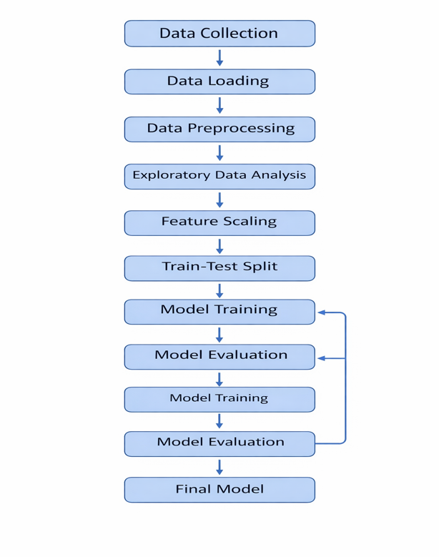

- Expected Modules/ Libraries to be used :

- NumPy - Used for numerical computations and handling arrays.
- Pandas - Used for loading, processing, and analyzing datasets.
- Scikit-learn - Used to implement machine learning algorithms and evaluation metrics.
- Matplotlib / Seaborn - Used to create graphs and data visualization plots.

- Expected Evaluation metrics and Plots to be used:

- Accuracy - Measures the overall correctness of the model predictions.
- Precision - Measures the proportion of correctly predicted positive cases.
- Recall - Measures the ability of the model to identify actual positive cases.
- F1-Score - Provides a balance between precision and recall.
- Confusion Matrix - Displays the number of correct and incorrect predictions.
- ROC Curve - Visualizes the performance of classification models.

- Required topics from the subject:

Following are the topics that we require are as follows ;

- Strings - Used for handling and processing textual data in the program.
- Files - Used to read and write dataset files such as CSV files.

- Platform Required:

- Jupyter notebook

- Books and Link Sources:

- Hands-On Machine Learning with Scikit-Learn and TensorFlow – Aurélien Géron
- Python for Data Analysis – Wes McKinney
- https://scikit-learn.org
- https://www.kaggle.com

